**Aim: Selection sort program using array and recursion**

* **Source Code** For section sort using array:

#include<iostream>

using namespace std;

int main()

{

int i,j,n,loc,temp,min,a[10];

cout<<"Enter the number of elements:";

cin>>n;

cout<<"\nEnter the elements\n";

for(i=0;i<n;i++)

{

cin>>a[i];

}

for(i=0;i<n-1;i++)

{

min=a[i];

loc=i;

for(j=i+1;j<n;j++)

{

if(min>a[j])

{

min=a[j];

loc=j;

}

}

temp=a[i];

a[i]=a[loc];

a[loc]=temp;

}

cout<<"\nSorted list is as follows\n";

for(i=0;i<n;i++)

{

cout<<a[i]<<" ";

}

return 0;

}

**OUTPUT**

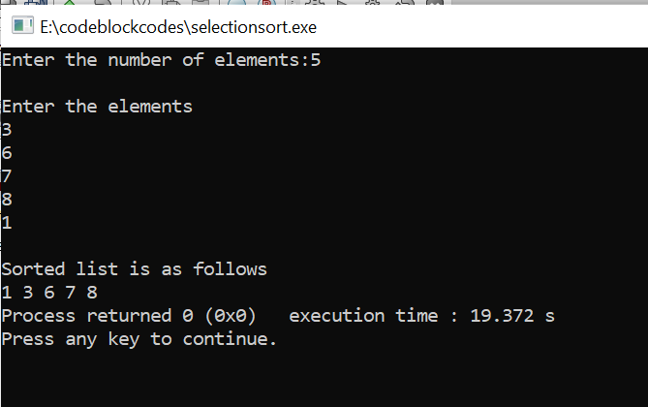

* **Source Code** For section sort using Recursion:

#include <iostream>

using namespace std;

int minIndex(int a[], int i, int j)

{

if (i == j)

return i;

int k = minIndex(a, i + 1, j);

return (a[i] < a[k])? i : k;

}

void recurSelectionSort(int a[], int n, int index = 0)

{

if (index == n)

return;

int k = minIndex(a, index, n-1);

if (k != index)

swap(a[k], a[index]);

recurSelectionSort(a, n, index + 1);

}

int main()

{

int arr[] = {3, 1, 5, 2, 7, 0};

int n = sizeof(arr)/sizeof(arr[0]);

recurSelectionSort(arr, n);

for (int i = 0; i<n ; i++)

cout << arr[i] << " ";

cout << endl;

return 0;

}

**OUTPUT:**

